Objet : | Specifications of a test bench for the automatic characterization of ultrasonic transducers
Reference/File: | 2017-09-01 SPEC echo_bench_transducer_test_bench en
Revision: | v1 | 2017-09-01 | BVi | Created
Revision: | v2 | 2017-12-01 | BVi | Template update
Revision: | In progress | 2017-12-04 | JBo | Translation FR->EN

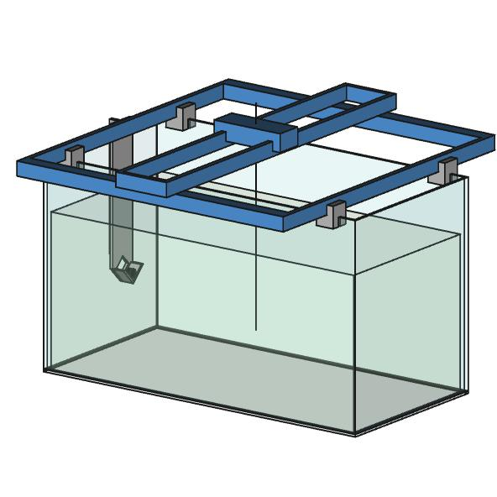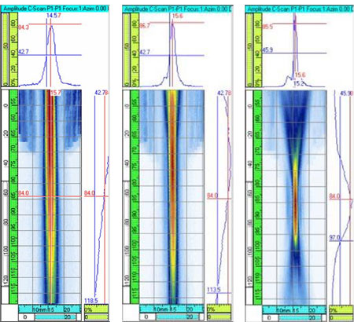

The test bench should allow precise and reproducible measurement of ultrasonic transducer performances:
- experimental identification of the optical focus;
- characterization of the sound field in two dimensions (for example on a 5 x 20cm plane);
- influence of diverse parameters on the measurement quality (tension, length of impulse, settings of the analogic acquisition);
- measurement of the variance of technical characteristics between different sensors of a same production batch;
- geometrical validation/correction of an image captured by a complete probe.
Knowing precisely the focus field of a transducer will allow the programming of corrective numerical end-of-pipe image processing algorithms (such as refocusing processes, for example provided here http://refocus-it.sourceforge.net/ and here http://www.focusmagic.com/)

Required hardware / part list du buy
Part | Sourcing
XY Plotter Robot from MakeBlock with Arduino controller | Purchased, 321€ incl. VAT, see for example here https://www.lextronic.fr/P30523-table-traante-plotter-xy-v20.html
Signal acquisition card US-SPI | US-SPI, Lecoeur Electronique  (http://www.lecoeur-electronique.net/crbst_16.html)
Raspberry Pi (ZERO or v3) | (ref. ???)
MMI Device | Any Device with a standard Browser

Hardware to be designed
Part | Sourcing
Aquarium feets | 3D printed
Universal transducer support | 3D printed
Target support | 3D printed
Electronic support | 3D printed

Communications

US-SPI
XY
Arduino controller
Raspberry
-100v
Stepper
SPI

USB
UART
SPI

TCP-IP
HTTP
Data

Here is an overview of exchanges between the different subsystems:
- Transducer ↔ US-SPI (low level analogic signal )
  - US-SPI provides a -100V pulse
  - Transducer returns an analogic signal
- US-SPI ↔ Raspberry Pi (binary commands on US-SPI, 5V, 8MHz)
  - Raspberry Pi provides pulse configuration and measurement order
  - US-SPI provides the measured raw data at 80Msps max.
- XY Robot ↔ Arduino controller (power electronics)
  - XY Robot provides sensed information such as axis position or limit switch
  - Arduino controller provides function signal to the motors and accessories
- Raspberry Pi ↔ Arduino XY table controller (ISO ASCII commands on USB, UART or SPI)
  - Raspberry Pi provides translation commands on axes XY (ISO code)
  - Arduino XY table confirms when required position is reached.
- Raspberry Pi ↔ Control interface (HTTP on Ethernet, WiFi or Ethernet over USB)
  - Control interface (web browser) allows setting measurement parameters (pulse settings, acquisition settings, surface to explore, etc.), manual control of the XY Robot and US-SPI (translation, test pulse, etc.)
  - Raspberry Pi provides the HTTP server with user interface pages and returns data files

Software
Following software development is required:
- HTTP server on Raspberry Pi programed with python (eventually with bottle) and providing
  - Communication with US-SPI
  - Communication with the Arduino XY table controller. Caution: the controller is designed to communicate via USB with a Windows PC rather than with a Raspberry Pi. In case this does not work, it will always be possible to control the XY Robot with the Rasberry Pi.
  - Display a measurement progression bar
  - Collect measurement files (referencing measurement conditions and sensor identifier)
- A graphical application for the visualization of the performed measurements with a basic database of measurement files (a simple in-browser graphic display would be nice). This application should allow exporting a directory per sensor.
Why a HTTP server? The long-term objective is to run the browser on a Raspbery Pi (v3 would be required in this case) connected to its own keyboard and monitor. That way, the test bench could be completely autonomous. This is an advantage because the measurement campaigns may be long and therefore immobilize material resources. It would be then possible to connect to the test bench through the network (local or internet [tricky?]).

Development and set up tasks
Task | Rough estimation of the required workload (in days)
Purchase | 1
Assembly of the XY Robot and initial set up | 2
3D printing of the aquarium feet, universal transducer support and target support | 2
Installation and configuration of the Raspberry | 2
Development of the communication library for the Raspberry Pi and XY Robot | 2
Development of the communication library for the Raspberry Pi and US-SPI | 2
Development of the HTTP server in python | 5
Data display | 4
Total | 20

Use cases
The test bench can be used to :
- Validate target design (e.g. material and shape);
- Characterize a reference transducer (e.g. Imasonic);
- Characterize purchased transducers;
- Validate samples for the flooding material (oils or other materials);
- Measure the perturbations introduced by acoustic mirrors;
- Perform calibration measurements to be used in numerical correction.

Transducer qualification protocol

…. In progress, to be completed ...

- Capture a photo of the transducer on 5mm x 5mm graph paper
- Write down the transducer references: manufacturer, product name, frequency, diameter, focus angle, focus length, dimensions of the focal zone at -6dB.
- Sentence to be translated
- Move the target to the focal point, where there is maxima echo and X. Set the verticality of the target. Set the horizontal angle by applying mechanical stress on the support tubes.
- Sentence to be translated.
- Set gain to 20dB and voltage to 70V. Set gMax just below the saturation level and raise voltage to let the curve touch the line 253. Write down the pair (gain, voltage).
- At 160Msps, capture an image of the echo (in png and json) for the following settings
  - Focal point, gMax. Save the result under “0dB.png/json”
  - Focal point, 60dB, target moved to -10mm on the Y axis. Save the result under “noise_-10mm_60dB.png/json”
  - Focal point, 60dB, target moved to -20mm on the Y axis. Save the result under “noise_-20mm_60dB.png/json”
  - -6dB, x max, gMax. Save the result under “-6dB_x_max.png/json”
  - -6dB, x min, gMax. Save the result under “-6dB_x_min.png/json”
  - Zero, ?dB (for the pulse <255). Save the result under “pulse.png/json”
- Go back to contact and Y=0. Sentence to be translated.
- Look for the delay which allows displaying the echo (generally within the 5-15µs range).
- Make a capture on 15x250 at 0.2x1mm with longitudinal sweeping.
- Save the captured image.
- Fill the measurement form to be archived with all the captured files.

Remaining improvements for this document
- Sequence diagram displaying communications between subsystems
- Set a parameter list for measurements (breadth, length, X delay, Y delay, etc.)
- Measurement types: single firing, exploration with fixed or progressive grid, smart exploration (looking for characteristic points)
- Define the characterization procedure of a transducer and the corresponding deliverable.



